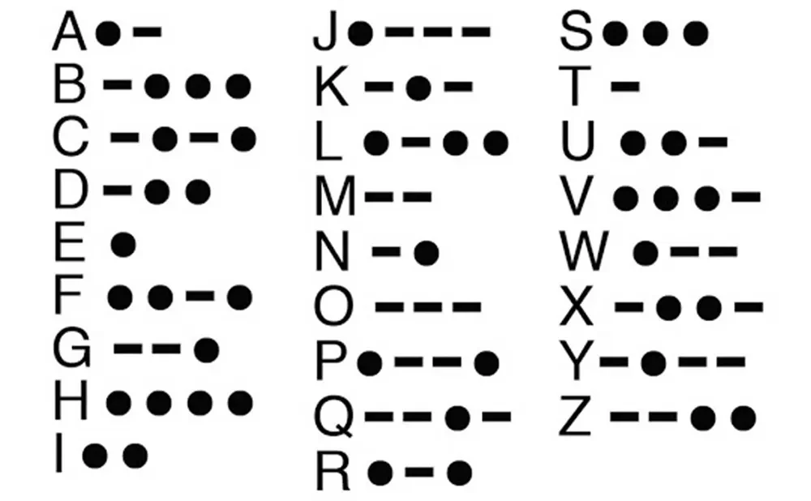  Iambic Morse Keyer and Trainer | Overview  A standalone embedded device that generates accurate iambic Morse code and helps users learn and practice Morse through adjustable speed control, on-screen feedback, and interactive training and decoding modes.  Seth Hibpshman  EENG 163-001

Iambic Morse Keyer and Trainer: Project Proposal
A hands-on embedded systems project focused on designing and programming a standalone iambic Morse code keyer that provides real-time feedback and basic training modes to reinforce timing, input handling, and user interaction fundamentals.

Seth A. Hibpshman
Student of Electrical Engineering
Eastern Washington University
EENG 163: Introduction to Embedded Systems
Draft #2
February 16, 2026

The cover image is provided by: Connie on retvis.com



Table of Contents
List of Figures iv
List of Tables v
Acronyms Used v
Project Background 1
What is the reason behind this project? 1
Why did you choose this project? 1
Is there any special benefit to this project besides it being fun? 1
Project Goals & Specification: By Version 1
Version 1.0 – Core Keyer Functionality 1
Hardware & Input/Output (I/O) 2
Software & Functionality 2
Specifications 2
Version 1.5 – Basic Display Integration 3
Hardware & I/O 3
Software & Functionality 3
Specifications 3
Version 2.0 – User Interface Enhancement: Settings Menu, Navigation, and Rotary Encoder 4
Hardware & I/O 5
Software & Functionality 5
Specifications 5
Version 2.5 - Training & Replay Modes 6
Hardware & I/O 6
Software & Functionality 6
Specifications 7
Version 3.0 – PCB & Enclosure 7
Hardware & I/O 7
Specifications 7
Version 4.0 – Communications Network Mode & STM32 Integration as a Communications Relay 8
Hardware & I/O 8
Software & Functionality 8
Specifications 8
Version 5.0 - Over-the-Air (OTA) Transmission/Decoding & Advanced Signal Processing 9
Hardware & I/O 9
Software & Functionality 10
Specifications 10
Expected Financial Costs 10
Labor 11
Hardware 11
Software 13
Tools Needed 13
Possible Issues & Risks 13
Work Breakdown Structure (Project Milestones) 13
I. Version 1.0 – Core Keyer Functionality – 01/30/26 14
II. Version 1.5 – Basic Display Integration – 02/06/26 14
III. Version 2.0 – User Interface Enhancement: Settings Menu, Navigation, and Rotary Encoder – 02/13/26 14
IV. Version 2.5 – Training & Replay Modes – 02/20/26 14
V. Version 3.0 – PCB & Enclosure – 02/27/26 14
VI. Version 4.0 – Communications Network Mode & STM32 Integration – 03/06/26 15
VII. Version 5.0 – Over-the-Air (OTA) Transmission/Decoding & Advanced Signal Processing – (Stretch) 15
References 16

List of Figures
Figure 1. v1.0 Schematic Sketch (Hibpshman, 2026). 2
Figure 2. v1.5 Schematic Sketch (Hibpshman, 2026). 3
Figure 3. v2.0 Schematic Sketch (Hibpshman, 2026). 5
Figure 4. v4.0 Schematic Sketch (Hibpshman, 2026). 8
Figure 5. Digital Signal Processing: Algorithmic Flow Chart (Hibpshman, 2026). 9

List of Tables
Table 1. Hardware Financial Breakdown by Part & Purpose (Hibpshman, 2026). 10

Acronyms Used

Computer Aided Design
(CAD) 6
Eastern Washington University
(EWU) 10
Electrically Erasable Programmable Read-Only Memory
(EEPROM) 4
Input/Output
(I/O) 1
Inter-Integrated Circuit
(I2C) 2
Light-Emitting Diode
(LED) 1
Organic Light Emitting Diode
(OLED) 2
Over-the-Air
(OTA) 8
Printed Circuit Board
(PCB) 2
Universal Asynchronous Receiver-Transmitter
(UART) 7
Universal Serial Bus
(USB) 12
Words-per-Minute
(WPM) 3

Project Background
This section attempts to provide personal insight into the team members’ thoughts on the project. Below is the testimonial of project lead: Seth Hibpshman.

What is the reason behind this project?
“The reason behind this project is to explore microcontrollers and their applications using MicroPython in the backend. A Morse Keyer has a lot of timing elements, external peripherals, potential decoding applications, UI design, and networking potential. These are a variety of tasks that can be explored with embedded systems.”

Why did you choose this project?
“I initially played around with a few ideas for a project. I wanted to do something I didn’t understand, and something that was complex enough for it to be hard for someone to replicate my work. Some of the initial ideas I played around with didn’t seem like they could challenge me as an Electrical & Computer Engineer, so I continued my research. The easiest way I could think of to fulfill my goals of the project (challenging & unique) was to increase the complexity. When breaking down concepts of Electrical Engineering, I also find it helpful to go back to history. Morse code and telegraph machines were some of the first long-distance communication devices. It was even more interesting how messages were sent with such limited signal transmission hardware. I thought this could be something interesting to replicate bottom up with a modern take on it.”

Is there any special benefit to this project besides it being fun?
“Well, my immediate thoughts are that this is a learning experience. It’s an opportunity to learn more about concepts I learned at university and apply them in the field. It allows me to delve deeper into the sub-discipline of embedded systems. This helps me refine my interest in Electrical Engineering as I progress in my career.”

Project Goals & Specification: By Version
Within the given timeframe and finances, the project team has outlined expectations for each project version. Each subsequent project version includes all the features from the last.

Version 1.0 – Core Keyer Functionality
Version 1.0 establishes the foundation of the standalone iambic Morse keyer. It emphasizes stable, reliable operation, providing immediate auditory and visual feedback to the user while implementing proper iambic timing.

Hardware & Input/Output (I/O)
- Design and build a functional standalone iambic Morse code keyer using a microcontroller.
- Implement three push buttons for “dit” and “dah” inputs. The additional button is to cycle through keying modes (Iambic A, Iambic B, Ultimatic, & Straight Key).
- Provide auditory feedback via a piezo buzzer.
- Provide visual feedback using a single Light-Emitting Diode (LED).

Software & Functionality
- Implement correct iambic A morse timing for reliable keying.
- Research button debouncing methods to prevent button inputs to prevent false triggers.
- Apply modular software structure, including separate modules for input handling, timing control, output synchronization, and display man agement.

Specifications
The Standalone Iambic Morse Keyer and Trainer shall function as a small, self-contained device approximately the size of a handheld gadget or small breadboard enclosure. The front panel will feature three push buttons clearly labeled for “dit” and “dah” input as well as the mode cycler button. Pressing these buttons will generate accurately timed Morse code elements according to standard iambic keying rules. This version supports multiple keyer modes, including Iambic A, Iambic B, Ultimatic, and Straight key operation, providing flexibility for different user preferences. A single LED will provide visual feedback for each signal, and a piezo buzzer will provide auditory confirmation.
Internally, the device will integrate an ESP32 microcontroller board, wiring, resistors, and buttons. Wires will be routed neatly on a prototyping breadboard as designed in Figure 1. The software will employ a modular structure separating input handling, timing control, display management, and output synchronization. The device will implement proper iambic A timing and incorporate debouncing methods to prevent false triggers. This version emphasizes stable, reliable operation with clean input/output feedback.

v1.0 Schematic Sketch (Hibpshman, 2026).
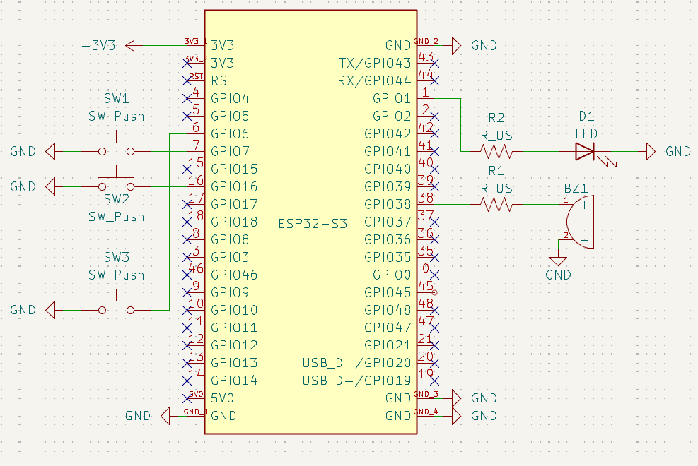

Version 1.5 – Basic Display Integration
Version 1.5 introduces visual output for enhanced user interaction. The display allows users to see input sequences in real time, supporting further development of training and operational modes.

Hardware & I/O
- SSD1306 128×64 Organic Light Emitting Diode (OLED) display integrated with the Inter-Integrated Circuit (I²C) protocol.

Software & Functionality
- Display current keying mode.
- Show keyed dits (periods) and dahs (dashes).
- Display hardcoded Words-per-Minute (WPM) for reference.

Specifications
This version extends Version 1.0 by visually representing Morse input and mode information on the OLED screen; dits will displayed as a period and dahs will be displayed as a dash as it is keyed. Wiring of the OLED screen can be seen in Figure 2. Users can track their keying and self-monitor performance, while the system maintains the same input handling, timing, and feedback mechanisms from the core version.

v1.5 Schematic Sketch (Hibpshman, 2026).
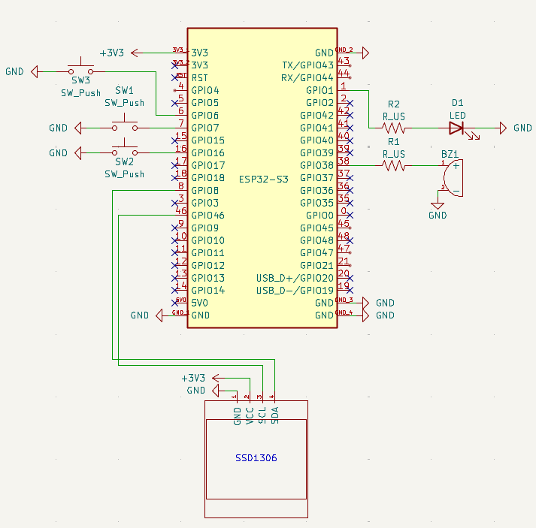

Version 2.0 – User Interface Enhancement: Settings Menu, Navigation, and Rotary Encoder
Version 2.0 adds user input through configurability, enabling control over operational parameters through a navigable menu. The rotary encoder interface provides intuitive interaction while preserving reliable signal generation.

Hardware & I/O
- Rotary encoder for user input for menu navigation and parameter adjustment.

Software & Functionality
- On-device menu system with mode-specific sub-settings.
- Adjustable parameters including tone frequency, WPM, and buzzer volume.
- Persistent storage of user settings in flash memory.
- Sleep mode and screen saver for energy efficiency.

Specifications
The integrated menu system allows the user to configure keyer behavior without sacrificing screen real estate. The rotary encoder can be held for two seconds, which will then display a settings menu. This menu has more items that will fit on the height of the screen, so scrolling was implemented. Displayed information includes active behavioral mode (to be implemented), keying input mode (Iambic A, B, Ultimatic, Straight Key), volume (0-10), LED enabled Boolean (Enabled, Disabled), morse decoding Boolean, scrollable about page (credits, sources, etc.), and device reset button. The rotary encoder is to be implemented as seen in Figure 3. Overall the settings menu allows a much higher configuration ability through the use of menus and scrolling.
Use of Electrically Erasable Programmable Read-Only Memory (EEPROM) ensures that preferences persist between sessions, while sleep mode reduces power consumption; the sleep mode includes a screensaver for visual flair.

v2.0 Schematic Sketch (Hibpshman, 2026).
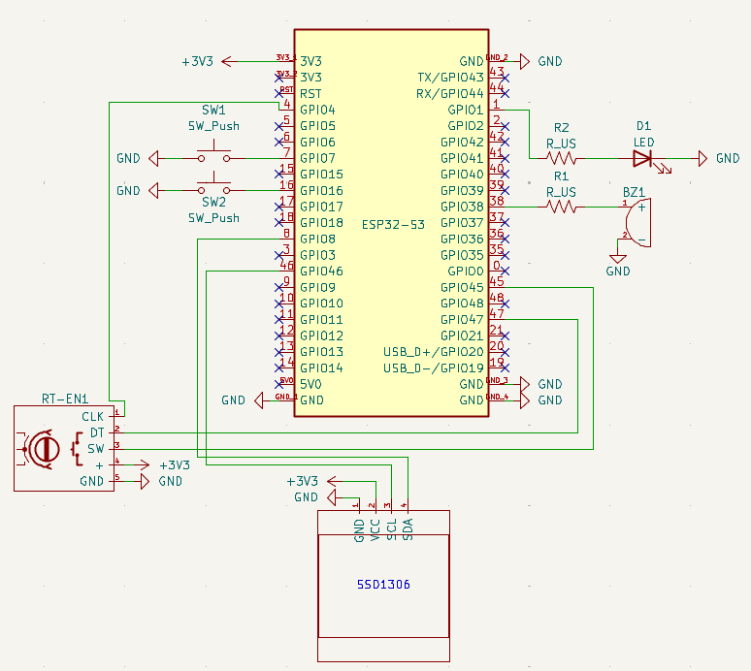

Version 2.5 - Training & Replay Modes
Version 2.5 introduces educational and practice features to enhance skill development. Training and Replay Modes allow users to practice accuracy, speed, and sequence recall.

Hardware & I/O
- 4×4 membrane keypad for custom alphabetic entry in Replay Mode.

Software & Functionality
- Training Modes: recall, replay, and pangram. Each mode will provide immediate feedback on correctness, and track session accuracy & scoring.
- Recall mode prompts the user for random letters, words, or short sentences.
- Alphabet and pangram challenges, including standard pangrams such as “The quick brown fox jumps over the lazy dog.”
- Replay Mode to reproduce custom sentences in Morse code.
- Dynamic WPM tracking over short intervals for performance evaluation.

Specifications
In the settings, the behavioral mode can be adjusted to either Sandbox (default mode) or Training. If Training is selected, then there will be dynamically visual sub-settings for that mode in the settings menu. The sub-settings include the training mode such as Recall, Replay, and Pangram.
The Recall mode randomly generates either individual letters, words, or sentences for the user to key back. The mode will then give feedback on correctness and speed. Similar to recall, pangram generates sentences for the user to key back, but it will include every letter in the alphabet, like the popular pangram “The quick brown fox jumps over the lazy dog”. Replay mode makes use of the 4×4 membrane keypad for alphabetic input. The input is in the style of an older phone where there are multiple letters per button, and pressing a button multiple times will change the current letter being typed.
Last, the dynamic WPM can be enabled in any training mode or Sandbox mode. It will track the user’s WPM over the last short period of time and display the live number on-screen.

Version 3.0 – PCB & Enclosure
Version 3.0 transitions the project to a finalized hardware platform with integrated PCB design and a protective enclosure, enhancing reliability, portability, and overall presentation.

Hardware & I/O
- Custom PCB integrating wiring, resistors, buttons, display, LEDs, buzzer, and rotary encoder.
- 3D-printed or custom enclosure with dedicated openings for paddles, display, and inputs.

Specifications
The device becomes a fully standalone unit suitable for desktop or portable use. The PCB ensures firm wiring connections and reduces risk of mechanical stress on wiring. All core features, functionality, and training modes remain intact and fully operational.
The design will be created in KiCad, the open-source PCB Computer Aided Design (CAD) tool. This includes potentially custom symbols, footprints, and layout of the PCB and schematic. The design can then be sent to an overseas manufacturer for reduced build costs; because of the shipping time and potential iterations involved in PCB design, this will be worked on prior to the implementation of all features.
3D-printed designs are modeled in AutoCAD, with the educational license for access. These designs can then be printed with university printers that can be found across campus.

Version 4.0 – Communications Network Mode & STM32 Integration as a Communications Relay
Version 4.0 adds networked communication capabilities, allowing the keyer to transmit and receive messages to a network of devices. This is implemented through a star topology where all devices (ESP32 nodes) and connected to a central hub/office (STM32 router). This enables multi-device integration and message relaying across a short distance.

Hardware & I/O
- STM32 microcontroller for communication relay.
- Auxiliary ports and cabling for ESP32–STM32 connection.

Software & Functionality
- Universal Asynchronous Receiver-Transmitter (UART) based communication between ESP32 and STM32.
- Mode selection for transmission, with target selection (office or another ESP32).
- Real-time message relaying across connected devices.

Specifications
This version extends the system to support distributed communication. Users can select targets for transmission, and messages are relayed in real time while preserving keyer functionality and display features. Each device will include an 3.5mm auxiliary jack to accommodate a 2-3 wire communication protocol between devices (Figure 4).
The ‘Transmission’ mode can be selected in the settings. The sub-setting of ‘Destination’ then becomes available. The user can either choose to transmit to the whole network or a specific device. Feedback will be provided if successfully connected, line busy, or no nodes available.

v4.0 Schematic Sketch (Hibpshman, 2026).
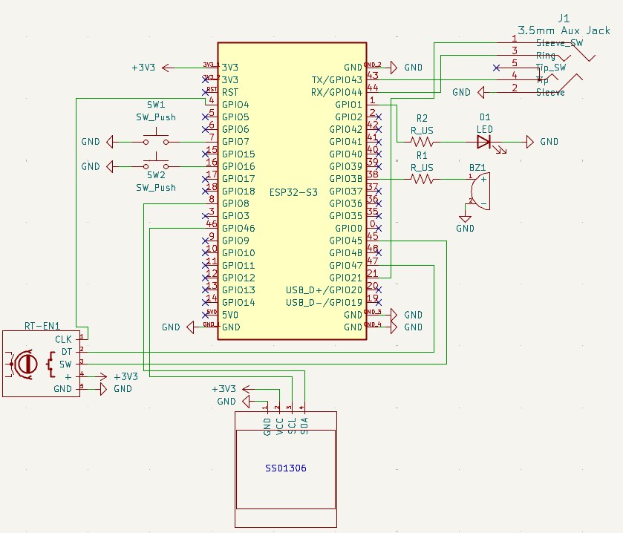

Version 5.0 - Over-the-Air (OTA) Transmission/Decoding & Advanced Signal Processing
This ‘feature’ is more of an additional project within this project, so it takes the least priority of all goals. Version 5.0 introduces advanced analog input and Over-the-Air transmission/decoding capabilities, expanding the keyer into experimental communication and signal processing applications.

Hardware & I/O
- Microphone or light-based analog input for alternative signal sources.
- Wi-Fi or Bluetooth module for OTA communication.

Software & Functionality
- Analog preprocessing with thresholding and debouncing.
- Timing estimation using ON/OFF duration histograms.
- Noise filtering and symbol extraction to identify dits and dahs.
- Advanced digital signal processing for source-agnostic decoding, including word segmentation and error correction.

Specifications
The system can now receive and process Morse code from a variety of analog sources. OTA transmission allows messages to be shared wirelessly, while signal processing ensures reliable reconstruction of text even in the presence of noise or irregular timing. This version represents the most advanced stage, combining all previous features with experimental communication and decoding capabilities.
Again, this is highly experimental. Device nodes can transmit data through the morse flashing of either an LED or soundwaves. The receiver node will include a corresponding sensor such as a sound sensor or photo-resistor. These analog values collected can then be sent through the interpretation and reconstruction algorithm detailed in Figure 5.

Digital Signal Processing: Algorithmic Flow Chart (Hibpshman, 2026).
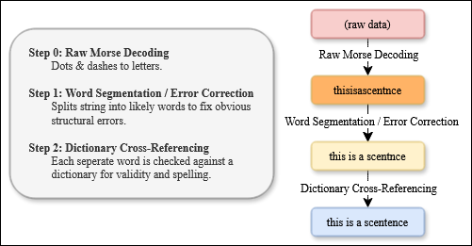

Expected Financial Costs
This section aims to provide an analysis of the potential costs associated with this project. This includes the cost of the employment of labor, hardware purchases, and software usages.

Labor
Most of the labor for this project is subsidized by Eastern Washington University (EWU) student(s) on a volunteer basis and thus minimal labor costs. Labor costs are not billed but should be noted in terms of hours and effort.
Cumulative total labor cost estimate: $0

Hardware
It is worth noting that bulk part purchasing costs are considered. One would not see such low prices for individual components unless buying 50-100 at once; the engineering team is incurring additional start-up costs. Moreover, hardware costs that can be salvaged or borrowed is also not considered; so there is potential for cost savings.
The following table summarizes the expected hardware components and associated costs for the project. Each part is noted in which version it is needed.

Hardware Financial Breakdown by Part & Purpose (Hibpshman, 2026).
Version | Category / Item | Quantity | Unit Cost | Total Cost | Notes
v1.0 – Core Keyer | ESP32-S3 Dev Board | 1 | $12 | $12 | Core processor
 | Push Buttons (momentary) | 3 | $0.05 | $0.15 | Dit / Dah inputs & mode switcher
 | Piezo Buzzer | 1 | $1 | $1 | Auditory feedback
 | LED (single) | 1 | $0.03 | $0.03 | Visual feedback
 | Resistors, wires, prototyping board | N/A | $5 | $5 | Mounting and connections
 | OLED 128×64 I²C | 1 | $3 | $3 | WPM, mode display
 | Subtotal v1.0 |  |  | $21.13 | Core keyer hardware only
v1.5 – Display Integration | OLED display already included | 1 | $0 | $0 | Already in v1.0
 | Subtotal v1.5 |  |  | $21.13 | No additional cost; software integration only
v2.0 – Menu / Rotary Encoder | Rotary Encoder with switch | 1 | $3 | $3 | Menu navigation
 | Subtotal v2.0 |  |  | $24.13 | Adds menu/navigation hardware
v2.5 – Training / Replay Modes | 3×3 Membrane Keypad | 1 | $5 | $5 | Replay Mode input
 | Subtotal v2.5 |  |  | $29.13 | Hardware for custom input
v3.0 – PCB & Enclosure | Plastic / 3D-printed case | 1 | $0 | $0 | Enclosure for PCB and components
 | PCBs | 3 |  | $15 | Neat wiring & stability
 | Subtotal v3.0 |  |  | $44.13 | No additional cost if 3D print available
v4.0 – STM32 & Comm Relay | STM32 Microcontroller | 1 | $10 | $10 | For communication relay experiments
 | Aux ports / cables | 1 | $2 | $13 | UART / auxiliary connections
 | A copy of all prior parts. |  |  | $29.13 | A 2nd ESP device on the communications network. (Didn’t include cost of 2nd PCB)
 | Subtotal v4.0 |  |  | $96.26 | Experimental communication hardware
v5.0 – Analog / OTA / DSP | Microphone / analog input | 1 | $3 | $3 | OTA / audio decoding experiments
 | Miscellaneous analog sensors | 1 | $2 | $2 | Light or threshold input
 | Subtotal v5.0 |  |  | $101.26 | Advanced input/processing hardware
Cumulative total hardware cost estimate: $101.26

Software
All software required for the project will be open-source or free for educational use:
- Notepad++ & PyCharm for firmware development.
- Free Python libraries for OLED display, rotary encoder, and buzzer output.
- KiCad for schematic and PCB design.
Cumulative total software cost estimate: $0

Tools Needed
Completion of the project will require access to the following tools:
- Soldering iron and solder
- Multimeter for testing electrical connections
- Power supply or Universal Serial Bus (USB) power source for the microcontroller
- Optional 3D printer or laser cutter if producing a custom enclosure
- Computer for programming and testing the microcontroller
Some tools may already be available in a university lab environment; otherwise, small purchases or lab access may be necessary.
Cumulative total tools needed cost estimate: $0-30

Possible Issues & Risks
The project involves multiple hardware and software subsystems that introduce technical and scheduling risks. The following items identify potential issues and mitigation strategies.

Timing Accuracy and Real-Time Constraints
Morse keying requires precise timing for dits, dahs, and inter-element spacing. Display updates, menu navigation, or background processing could introduce latency and disrupt signal accuracy. This risk will be mitigated by separating timing control from user interface tasks and prioritizing real-time signal generation.

Button Debouncing and Input Reliability
Mechanical push buttons and keypads may generate false triggers due to contact bounce. Improper debouncing could lead to incorrect symbol generation or menu navigation errors. Software debouncing and validation through oscilloscope or serial timing measurements will be used to ensure stable input handling.

Flash Memory Wear and Data Integrity
Frequent writing of settings to flash memory may reduce memory lifespan or lead to corrupted configuration data. Writes will be limited to events where settings are changed, and default recovery values will be implemented in case of read failure.

Power Consumption and Sleep Mode Behavior
Improper sleep implementation may cause the device to fail to wake reliably or may not provide meaningful power savings. Power states will be tested under multiple usage scenarios to ensure correct wake behavior and stable operation.

User Interface Complexity
The rotary encoder menu system and mode-dependent sub-settings introduce additional software complexity. There is a risk of navigation errors, inaccessible settings, or state conflicts between modes. This will be addressed through structured state management and incremental testing of each menu layer.

Keypad Multi-Tap Input Ambiguity
Replay Mode uses multi-tap character selection, which introduces timing thresholds for character confirmation. Incorrect timing windows may lead to unintended character selection. Adjustable timeout parameters and visual confirmation of the current character will reduce this risk.

PCB Design Errors
Schematic or footprint mistakes may result in incorrect pin mapping, insufficient trace clearance, or power routing issues. Design rule checks, peer review, and prototype testing on a breadboard prior to fabrication will reduce the likelihood of costly board revisions.

Mechanical Fit and Enclosure Constraints
Improper enclosure dimensions may obstruct connectors, displays, or input devices. A prototype enclosure will be test-fitted using cardboard or low-cost prints before final fabrication.

UART Communication Synchronization
Version 4.0 introduces inter-device communication through UART. Mismatched baud rates, framing errors, or buffer overruns could interrupt message relaying. Communication protocols will include handshake validation and error detection to ensure reliable transmission.

Network Topology Scaling
The star topology using a central relay may become a bottleneck if multiple nodes transmit simultaneously. A basic queueing or busy-state signaling mechanism will be implemented to prevent data collisions. This is also limited by the number of UART ports on the STM32 model used.

Analog Signal Noise in OTA Experiments
Microphone and light-based decoding are susceptible to environmental noise and inconsistent signal amplitude. Threshold calibration, filtering, and histogram-based timing analysis will be used to improve symbol detection reliability.

Project Scope and Time Constraints
Later versions, particularly PCB fabrication, STM32 integration, and OTA decoding, depend on earlier milestones. Delays in hardware delivery or debugging could limit the ability to complete advanced features. The versioned structure allows the project to remain functional even if stretch goals are deferred.

Component Availability and Shipping Delays
PCB fabrication and certain components may require overseas ordering with variable shipping times. Early ordering and maintaining breadboard-based functionality as a fallback will mitigate schedule impact.

Tool and Lab Access
Limited access to soldering equipment, multimeters, or 3D printers may delay hardware integration. Backup plans include scheduling lab time in advance and maintaining modular test configurations.

Work Breakdown Structure (Project Milestones)
The team has sketched out project milestones that they expect to reach once the project is approved by the client. If goals are met quicker than expected, the team will immediately start working on the next milestone. If all milestones are completed, the team shall work on the stretch goals outlined.
The client is adamant about the integration of the STM32 microcontroller into the project. This will be integrated in version 4.0; version 4.0 will be prioritized over other milestones as the deadline approaches.
Firm project milestones can be negotiated with the client, but the timeline will remain flexible as the labor power of the project is completely comprised of university students.

I. Version 1.0 – Core Keyer Functionality – 01/30/26
Implement the foundational standalone iambic Morse keyer using three push buttons for “dit,” “dah,” and mode cycling. Ensure accurate timing for Iambic A, Iambic B, Ultimatic, and Straight key modes. Provide synchronized auditory feedback through the piezo buzzer and visual feedback using a single LED. Implement reliable button debouncing and verify stable real-time signal generation on a prototyping platform.

II. Version 1.5 – Basic Display Integration – 02/06/26
Integrate the SSD1306 128×64 OLED via I²C. Display keyed dits and dahs in real time along with the active keying mode and a fixed WPM reference. Validate that display updates do not interfere with timing accuracy or output synchronization. Confirm stable operation with continuous input and output activity.

III. Version 2.0 – User Interface Enhancement: Settings Menu, Navigation, and Rotary Encoder – 02/13/26
Implement a rotary encoder-driven menu system with scrolling support and long-press activation. Add adjustable parameters including WPM, tone frequency, buzzer volume, LED enable state, and decoding toggle. Implement persistent storage of settings in flash memory and verify correct restoration on boot. Add sleep mode with a screen saver and confirm reduced power behavior without disrupting wake functionality.

IV. Version 2.5 – Training & Replay Modes – 02/20/26
Develop Training Modes including Recall, Alphabet, Pangram, and Replay. Integrate the 4×4 membrane keypad for multi-letter input in Replay Mode using multi-tap character selection. Implement real-time correctness feedback, session scoring, and dynamic WPM tracking over short intervals. Add mode-specific sub-settings that appear only when the corresponding behavioral mode is active. Validate accurate performance evaluation and responsive user interaction.

V. Version 3.0 – PCB & Enclosure – 02/27/26
Design the complete schematic and PCB layout in KiCad, including custom symbols and footprints as required. Route all components for a compact, reliable standalone board. Submit the PCB for fabrication and begin enclosure design in AutoCAD with cutouts for paddles, display, encoder, keypad, LED, buzzer, and auxiliary ports. Assemble and test the fabricated PCB to confirm full functionality of all previously implemented features.

VI. Version 4.0 – Communications Network Mode & STM32 Integration – 03/06/26
Integrate STM32 as a central communication relay using UART connections through auxiliary ports. Implement Transmission Mode with destination selection (specific node or broadcast). Provide connection status feedback including successful link, line busy, and no-node conditions. Validate real-time message relaying between devices while maintaining full keyer and display functionality.

VII. Version 5.0 – Over-the-Air (OTA) Transmission/Decoding & Advanced Signal Processing – (Stretch)
Begin experimental implementation of analog signal reception using microphone and light-based sensors. Develop preprocessing stages including thresholding, debouncing, ON/OFF duration measurement, noise filtering, and dit/dah classification. Implement basic OTA transmission via LED or audio output and reconstruct decoded text using timing-based algorithms. Explore higher-level processing such as word segmentation and error correction as time permits.

References
Hibpshman, S. (2026, January). Cheney, Washington, United States of America.

